**ЛАБОРАТОРНА РОБОТА № 4**

***Мета:*** ОБЧИСЛЕННЯ ПРОСТИХ ЦІЛОЧИСЛЕНИХ ВИРАЗІВ НА МОВІ ASSEMBLER

**Хід роботи:**

Завдання 1:

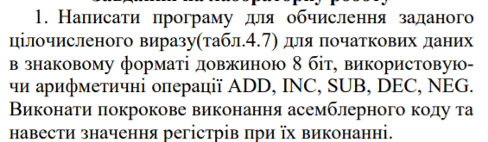



Лістинг програми:

#include <stdio.h>

#include <cstdlib>

#include <tchar.h>

int main(int argc, _TCHAR* argv[])

{

char a, b, c, d, e, f, res_c, res_asm=0;

printf("a = "); scanf_s("%d", &a);

printf("b = "); scanf_s("%d", &b);

printf("c = "); scanf_s("%d", &c);

printf("d = "); scanf_s("%d", &d);

printf("e = "); scanf_s("%d", &e);

printf("f = "); scanf_s("%d", &f);

res_c = f - (a + c - b + e) - (d + 2) + 3;

printf("RESULT C=%d\n", res_c);

_asm

{

mov al, a;//<al>=a;

add al, c;//<al>=a+c

sub al, b;//<al>=a+c-b

add al, e;//<al>=a+c-b+e;

mov bl, d;//<bl>=d

add bl, 2;//<bl>=d+2

mov cl, f;//<cl>=f

sub cl, al;//<cl>=f-(a+c-b+e)

sub cl, bl;//<cl>=f-(a+c-b+e)-(d+2)

add cl, 3;//<cl>=f-(a+c-b+e)-(d+2)+3

add res_asm, cl;

}

printf("Result ASM= %d\n", res_asm);

system("Pause"); return 0;

}

**Результат виконання:**

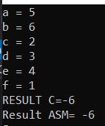

|  |  |  |  |  |  |  |  |
| --- | --- | --- | --- | --- | --- | --- | --- |
| Крок | Ко | манда | Значення регiстра | | |  | EFLAGS/FLAGS  (CF, OF) |
| al | bl | cl | dl |
| 1 | mov al, | a | 5 | н/в | н/в | н/в | --- |
| 2 | add al, | c | 7 | н/в | н/в | н/в | --- |
| 3 | sub al, | b | 1 | н/в | н/в | н/в | --- |
| 4 | add al, | e | 5 | н/в | н/в | н/в | --- |
| 5 | mov bl, | d | н/в | 3 | н/в | н/в | --- |
| 6 | add bl, | 2 | н/в | 5 | н/в | н/в | --- |
| 7 | add cl, | f | н/в | н/в | 1 | н/в | --- |
| 8 | sub cl, | al | н/в | н/в | -4 | н/в | --- |
| 9 | sub cl, | bl | н/в | н/в | -9 | н/в | --- |
| 10 | add cl, | 3 | н/в | н/в | -6 | н/в | --- |
| 11 | mov res_asm, al | | н/в | н/в | н/в | н/в | --- |

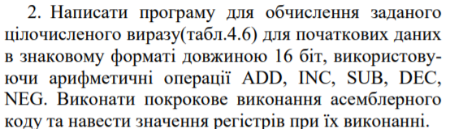



Лістинг програми:

#include <stdio.h>

#include <cstdlib>

#include <tchar.h>

int main(int argc, _TCHAR* argv[])

{

short int a, b, c, d, e, f, res_c, res_asm=0;

printf("a = "); scanf_s("%d", &a);

printf("b = "); scanf_s("%d", &b);

printf("c = "); scanf_s("%d", &c);

printf("d = "); scanf_s("%d", &d);

printf("e = "); scanf_s("%d", &e);

printf("f = "); scanf_s("%d", &f);

res_c = f - (a + c - b + e) - (d + 2) + 3;

printf("RESULT C=%d\n", res_c);

_asm

{

mov ax, a;//<ax>=a;

add ax, c;//<ax>=a+c

sub ax, b;//<ax>=a+c-b

add ax, e;//<ax>=a+c-b+e;

mov bx, d;//<bx>=d

add bx, 2;//<bx>=d+2

mov cx, f;//<cx>=f

sub cx, ax;//<cx>=f-(a+c-b+e)

sub cx, bx;//<cx>=f-(a+c-b+e)-(d+2)

add cx, 3;//<cx>=f-(a+c-b+e)-(d+2)+3

add res_asm, cx;

}

printf("Result ASM= %d\n", res_asm);

system("Pause"); return 0;

}

**Результат виконання:**

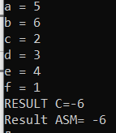

|  |  |  |  |  |  |  |  |
| --- | --- | --- | --- | --- | --- | --- | --- |
| Крок | Ко | манда | Значення регiстра | | |  | EFLAGS/FLAGS  (CF, OF) |
| ax | bx | cx | dx |
| 1 | mov ax, | a | 5 | н/в | н/в | н/в | --- |
| 2 | add ax, | c | 7 | н/в | н/в | н/в | --- |
| 3 | sub ax, | b | 1 | н/в | н/в | н/в | --- |
| 4 | add ax, | e | 5 | н/в | н/в | н/в | --- |
| 5 | mov bx, | d | н/в | 3 | н/в | н/в | --- |
| 6 | add bx, | 2 | н/в | 5 | н/в | н/в | --- |
| 7 | add cx, | f | н/в | н/в | 1 | н/в | --- |
| 8 | sub cx, | ax | н/в | н/в | -4 | н/в | --- |
| 9 | sub cx, | bx | н/в | н/в | -9 | н/в | --- |
| 10 | add cx, | 3 | н/в | н/в | -6 | н/в | --- |
| 11 | mov res_asm, ax | | н/в | н/в | н/в | н/в | --- |

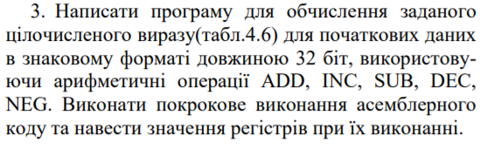



Лістинг програми:

#include <stdio.h>

#include <cstdlib>

#include <tchar.h>

int main(int argc, _TCHAR* argv[])

{

int a, b, c, d, e, f, res_c, res_asm=0;

printf("a = "); scanf_s("%d", &a);

printf("b = "); scanf_s("%d", &b);

printf("c = "); scanf_s("%d", &c);

printf("d = "); scanf_s("%d", &d);

printf("e = "); scanf_s("%d", &e);

printf("f = "); scanf_s("%d", &f);

res_c = f - (a + c - b + e) - (d + 2) + 3;

printf("RESULT C=%d\n", res_c);

_asm

{

mov eax, a;//<eax>=a;

add eax, c;//<eax>=a+c

sub eax, b;//<eax>=a+c-b

add eax, e;//<eax>=a+c-b+e;

mov ebx, d;//<ebx>=d

add ebx, 2;//<ebx>=d+2

mov ecx, f;//<ecx>=f

sub ecx, eax;//<ecx>=f-(a+c-b+e)

sub ecx, ebx;//<ecx>=f-(a+c-b+e)-(d+2)

add ecx, 3;//<ecx>=f-(a+c-b+e)-(d+2)+3

add res_asm, ecx;

}

printf("Result ASM= %d\n", res_asm);

system("Pause"); return 0;

}

**Результат виконання:**

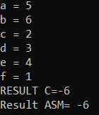

|  |  |  |  |  |  |  |  |
| --- | --- | --- | --- | --- | --- | --- | --- |
| Крок | Ко | манда | Значення регiстра | | |  | EFLAGS/FLAGS  (CF, OF) |
| eax | ebx | ecx | edx |
| 1 | mov eax, | a | 5 | н/в | н/в | н/в | --- |
| 2 | add eax, | c | 7 | н/в | н/в | н/в | --- |
| 3 | sub eax, | b | 1 | н/в | н/в | н/в | --- |
| 4 | add eax, | e | 5 | н/в | н/в | н/в | --- |
| 5 | mov ebx, | d | н/в | 3 | н/в | н/в | --- |
| 6 | add ebx, | 2 | н/в | 5 | н/в | н/в | --- |
| 7 | add ecx, | f | н/в | н/в | 1 | н/в | --- |
| 8 | sub ecx, | eax | н/в | н/в | -4 | н/в | --- |
| 9 | sub ecx, | ebx | н/в | н/в | -9 | н/в | --- |
| 10 | add ecx, | 3 | н/в | н/в | -6 | н/в | --- |
| 11 | mov res_asm, eax | | н/в | н/в | н/в | н/в | --- |

***Висновки:*** Ми набули навчиок простих обчислень на мові Assembler.